Practical Aim To implement hash tables using different collision handling strategies and develop the ability to reason about why collisions occur, how different strategies resolve them, and what trade-offs each approach involves.
Problem 1 A small parking lot has exactly 10 numbered slots (0 to 9). When a vehicle arrives, its registration number is used to assign it a slot by taking the last digit of the number. If that slot is already taken, the vehicle moves to the next available slot in order, wrapping around if necessary. Given a sequence of vehicle registrations, assign each to a slot using this rule and display the final state of all ten slots. Describe what your solution does when it encounters an already occupied slot. What happens when the parking lot is nearly full and many vehicles keep landing on the same slot? Can you think of a situation where your solution might loop indefinitely?
CODE:
#include <iostream>
using namespace std;
int main()
{
int table[10];
int n, id, slot;
for (int i = 0; i < 10; i++)
table[i] = -1;
cout << "Enter number of vehicles: ";
cin >> n;
if (n < 0 || n > 10)
{
cout << "Enter vehicles between 0 and 10.";
return 0;
}
for (int i = 0; i < n; i++)
{
cout << "Enter vehicle registration number: ";
cin >> id;
slot = id % 10;
int count = 0;
while (table[slot] != -1 && count < 10)
{
slot = (slot + 1) % 10;
count++;
}
if (count == 10)
cout << "Parking lot is full. Vehicle cannot be parked.\n";
else
table[slot] = id;
}
cout << "\nFinal Parking Slots:\n";
for (int i = 0; i < 10; i++)
{
cout << "Slot " << i << ": ";
if (table[i] == -1)
cout << "Empty";
else
cout << table[i];
cout << endl;
}
return 0;
}
OUTPUT:
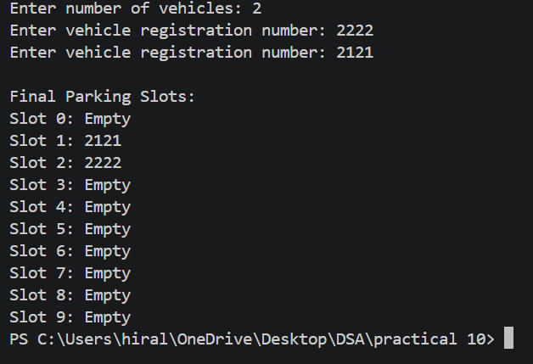
Problem 2 A library uses a system with 10 shelves numbered 0 to 9. Each book's code is used to decide which shelf it belongs to by taking the code modulo 10. Unlike the parking lot, each shelf can hold multiple books stacked together — when two books map to the same shelf, they are simply added to that shelf's stack. Given a sequence of book codes, place each on the correct shelf and display the final contents of all shelves. Describe how your solution handles two books that map to the same shelf. What happens to search time on a shelf as more and more books pile onto it? Can you think of what would cause all books to end up on the same shelf?
CODE:
#include <iostream>
using namespace std;
struct Node
{
int code;
Node* next;
};
int main()
{
Node* table[10];
int n, code, slot;
for (int i = 0; i < 10; i++)
table[i] = NULL;
cout << "Enter number of books: ";
cin >> n;
if (n < 0)
{
cout << "Invalid number of books.";
return 0;
}
for (int i = 0; i < n; i++)
{
cout << "Enter book code: ";
cin >> code;
slot = code % 10;
Node* newNode = new Node;
newNode->code = code;
newNode->next = NULL;
if (table[slot] == NULL)
{
table[slot] = newNode;
}
else
{
Node* temp = table[slot];

while (temp->next != NULL)
temp = temp->next;

temp->next = newNode;
}
}
cout << "\nFinal Hash Table:\n";
for (int i = 0; i < 10; i++)
{
cout << "Shelf " << i << ": ";
Node* temp = table[i];
while (temp != NULL)
{
cout << temp->code << " -> ";
temp = temp->next;
}
cout << "NULL" << endl;
}
return 0;
}
OUTPUT:
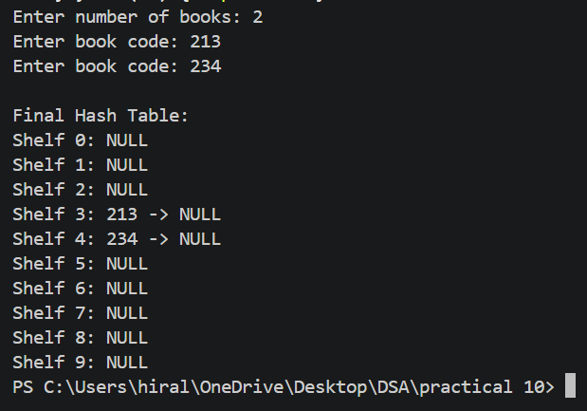

Problem 3 A university assigns student IDs to storage slots using a two-step rule. The first rule determines the initial slot. If that slot is taken, instead of simply moving one slot forward, a second rule based on the ID itself determines how many slots to jump. This means different IDs that collide will probe different sequences of slots, spreading them more evenly. Given a sequence of student IDs, assign each to a slot using both rules and display the final state of the table. Page 32 DSA Lab Manual (CSUC201) CSE Department, CHARUSAT Describe how your solution decides how many slots to jump when a collision occurs. What is the risk if the jump size happens to be a factor of the table size? How does this strategy differ from Problem 10.1 in how it spreads collisions?
CODE:
#include <iostream>
using namespace std;
int main()
{
int table[10];
int n, id, h1, h2, slot;
for (int i = 0; i < 10; i++)
table[i] = -1;
cout << "Enter number of student IDs: ";
cin >> n;
if (n < 0 || n > 10)
{
cout << "Enter IDs between 0 and 10.";
return 0;
}
for (int i = 0; i < n; i++)
{
cout << "Enter student ID: ";
cin >> id;
h1 = id % 10;
h2 = 7 - (id % 7);
int j = 0;
while (j < 10)
{
slot = (h1 + j * h2) % 10;
if (table[slot] == -1)
{
table[slot] = id;
break;
}
j++;
}
if (j == 10)
cout << "Cannot insert ID " << id << endl;
}
cout << "\nFinal Hash Table:\n";
for (int i = 0; i < 10; i++)
{
cout << "Slot " << i << ": ";
if (table[i] == -1)
cout << "Empty";
else
cout << table[i];
cout << endl;
}
return 0;
}
OUTPUT:
